**Evolution view**

This section analyses the evolution of the elasticsearch. The evolution view focuses on identifying the ability to be flexible in the face of inevitable change. As is known to all in the IT field , a flexible system should be able to deal with all possible types of changes that it may experience during its lifetime [1]. Therefore, the changes throughout the lifetime of the project are analysed.

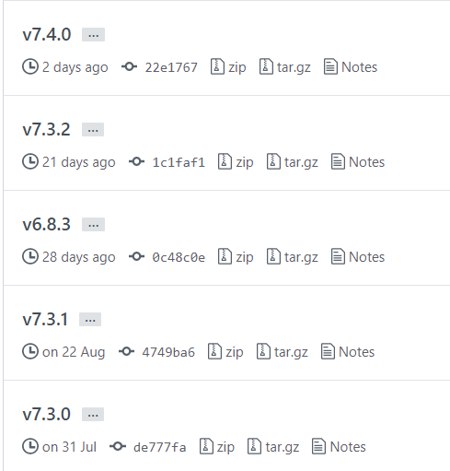

Figure: The latest 5 releases of Elasticsearch

The main reason for Elasticsearch to innovate and change the project structure is to improve the product. Up till now, Elasticsearch has for 258 releases. In every iteration, it attempts to add new features and improve performance and user experience significantly.

The latest release is Elasticsearch 7.4.0, released on 10/1/2019. In this release, developers update the schema for the REST API specification, improve progress reporting for data frame analytics, forbid empty doc values on vector functions, use float instead of double for query vectors and provide an option to use Path-Style-Access with S3 Repo.As for Java changes, they change order of parameter in Geometries to lon, late. for network, they stop recreating Wrapped Handlers in RestController. In the meanwhile, developers do some deprecations. They add Geometry-based query builders to QueryBuilders and Add deprecation check for pidfile setting. They Deprecate the pidfile setting and the setting processors to more than available.

In order to make the functions of Elasticsearch more complete, the new product has some new features and enhancement for many aspects, such as Aggregations, Analysis, Authentication, Authorization and so on.